Stay-Close platform

**It has an estimate of 9 pages.**

* Landing page
* Signing up/login page
* Guest dashboard
* Host Dashboard
* Confirmation Step (Property)
* Listing of property page
* Error pages
* View property page
* The help centre page
* Feedback page

1. **Under the landing page**

* Property filters buttons
  + All,
  + House
  + BNB
  + More
* Main search filter
  + Check in and check out date
  + Number of guest
  + Number of children
  + Minimum amount
  + Maximum amount
  + Location
* Other search filters
  + Check in and check out date
  + Filter by type of place
    - Entire place
    - Room
    - Shared room
  + Filter by price
    - Minimum and maximum amount
  + Filter by no. of rooms, beds & bathroom
    - For each: Any, 1-5+
  + Filter by amenities (essentials)
    - Eg. Bathtub, bed, and etc
  + Filter by amenities (features)
    - Eg. Swimming pool, TV, Wifi and etc
* Account button
  + Sign up
  + Log in
  + List your home
* List your home button
  + Sign up/in as a host
* Listings
  + Sign up when you click it
* Up button (used to scroll back up)

1. **Under Signing up page**

* Sign up as a host
  + First name
  + Last name
  + Date of birth
  + Email address
  + Phone number
  + Whatsapp number
  + Password
  + Confirm Password
  + **After you sign up as host’**
    - Create their profile
      * Upload profile picture (No Skip)
    - Property listing steps (**Refer to listing steps page**)
    - Redirect to Host dashboard (**Refer to Host dashboard page)**
* Sign up as a guest
  + First name
  + Last name
  + Date of birth
  + Email address
  + Phone number
  + Whatsapp number
  + Password
  + Confirm Password
  + **After guest signs up**
    - Create their profile
      * Upload profile picture or skip
    - Redirect to Guest Dashboard (**Refer to Guest dashboard page)**

1. **Login page**

Login as Guest

* Email address
* Password
* Forgot password
* **After successful login**
  + Redirect to Guest Dashboard (**Refer to Guest dashboard page)**

Login as Host

* Email address
* Password
* Forgot password
* **After successful login**
  + Redirect to Host Dashboard (**Refer to Host dashboard page)**

1. **Guest Dashboard**

* Property filters buttons
  + All,
  + House
  + BNB
  + More
* Main search filter
  + Check in and check out date
  + Number of guest
  + Number of children
  + Minimum amount
  + Maximum amount
  + Location
* Other search filters
  + Check in and check out date
  + Filter by type of place
    - Entire place
    - Room
    - Shared room
  + Filter by price
    - Minimum and maximum amount
  + Filter by no. of rooms, beds & bathroom
    - For each: Any, 1-5+
  + Filter by amenities (essentials)
    - Eg. Bathtub, bed, and etc
  + Filter by amenities (features)
    - Eg. Swimming pool, TV, Wifi and etc
* Drop down Manu button
  + Messages page
    - Displays a host and button to chat with host
    - **After clicking the button**
      * Open chat service page
  + Notifications page
    - Displays a summary of the message and button to display the entire message
  + Trips/Reservations page
    - Pending button
      * Show pending reservations
    - Accepted button
      * Shows accepted reservations
    - Rejected button
      * Shows rejected reservations
    - History button
      * All of the successful trips
  + Wishlist page
    - Shows all of your liked properties
  + Manage listings page
    - Requires you to have a Host account so that you can manage your listings
  + Account page
    - Update or view the profile picture
    - Personal information pop up
    - Payment page
    - Profile preferences pop-up.
    - Log in and security pop-up.
  + Wallet page
    - Wallet credit balance
    - Refunds
    - Booking History
  + Help centre page
    - Feedback And report forms
    - FAQ
  + Logout button

1. **Host Dashboard**

Today’s page

* + Confirmation button (displays property confirmation)
    - **After clicking (**Refer to Confirmation steps)
  + Checking in button (displays guest check in today)
    - Display the guest who checked in and the property they are in
  + Checking out button (displays guest check out today)
    - Display the guest who checked out and the property they are out
  + Reservations (Displays properties booked today)
    - Reservations requests from guest with buttons Reject or Accept

Listings Page

* + Displays all the property listings
  + Button to view the property
    - Entire information about the property
      1. Basic information about the property: Eg property name, location, pictures, hosting options and etc.
      2. Amenities: Eg- Basic amenities and stand out amenities
      3. Availability dates and check in and check out times.
      4. Pricing tap: Listing price, discounts, cleaning fees
      5. Cancellation and house rules: Update cancellation policy and house rules
      6. Delete listing button
  + Add listings button(refer to the listings steps page)

Reservation Page

* + Current button (displays current reservations)
  + Rejected button (displays rejected reservations)
  + History (displays all completed)

Earnings Page

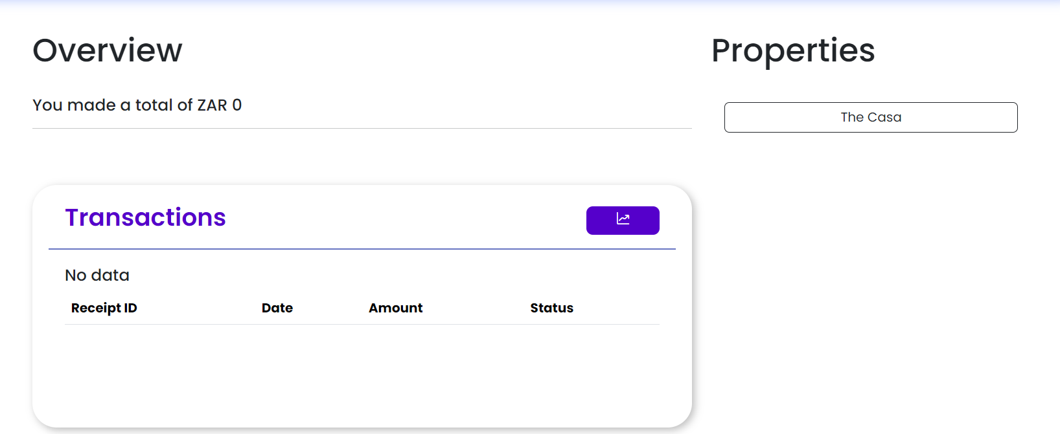

* + This summarizes the earnings of all properties.
  + Property button they show you specific earnings for each property.

Insights page

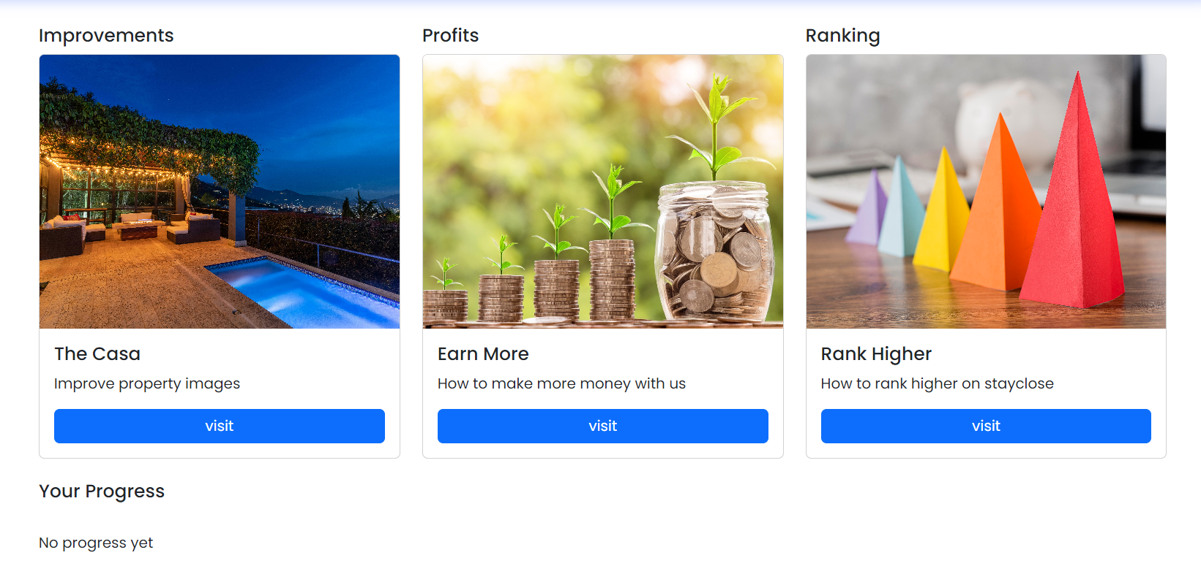

* + After clicking the visit button, it should give you more information about that particular insight.

Co-Hosting

* + When you click on it; it will give you a prompt to invite a host Agent.
  + That host should be registered as a Host Agent
  + The host my assign privileges to the host Agent
  + The host Agent will have their own host dashboard with the privileges provided by the host.

Chat page

* Display all the guest that have booked a specific property.
* There is a button that will open a chat room between the host and the guest.
* When they click the help button; it should allow them to send a query to StayClose.

Reviews Page

* Displays all the guest reviews about the property
* The should also be able to review the guest and rate them

New listing button

* Redirect you to the listings steps.

Notification pop-up button (Display all the host notifications)

Account button.

* Update or view the profile picture
* Personal information pop up
* Payment page
* Profile preferences pop-up.
* Taxes
* Log in and security pop-up.

Help centre page

* Feedback And report forms
* FAQ

Logout button